**Road Traffic Signal**

**SUBMITTED BY**

Abdul Rafay Zahid (65540)

Emaz Ali Khan (65566)

Wali Ijaz Ul Haq (65537)

**SUPERVISED BY**

SANA ALI KHAN



REPORT SUBMITTED TO THE FACULTY OF COMPUTING, KARACHI INSTITUTE OF ECONOMICS AND TECHNOLOGY, IN PARTIAL FULFILMENT OF THE REQUIREMENTS FOR THE DEGREE OF BACHELOR OF SCIENCE IN COMPUTER SCIENCE

SPRING 2024

* **Introduction:**

This report investigates a fundamental traffic light circuit constructed using the ubiquitous 555 timer IC. The 555 timer's astable mode creates oscillating outputs that dictate the sequence and timing of Red, Yellow, and Green LEDs, replicating a real traffic light system. This project serves as a practical introduction to electronics concepts like astable multivibrators, timing circuits, and LED control, offering valuable insight into the underlying principles of traffic light operation.

* **Working:**

This traffic light circuit utilized a 555 timer in astable mode. Here, we employ two interconnected 555 timers configured as astable multivibrators. The key difference lies in how these timers are cascaded. The first 555 timer dictates the timing for the Red LED. Its output controls the power supply to the second 555 timer. This ensures that the second timer, responsible for Green and Yellow LEDs, is only operational when the first timer (Red LED) is off. This configuration establishes a timed sequence: the Green LED illuminates first, followed by a brief yellow transition period, and finally the Red LED takes over as the cycle restarts.

* **Circuit Diagram:**

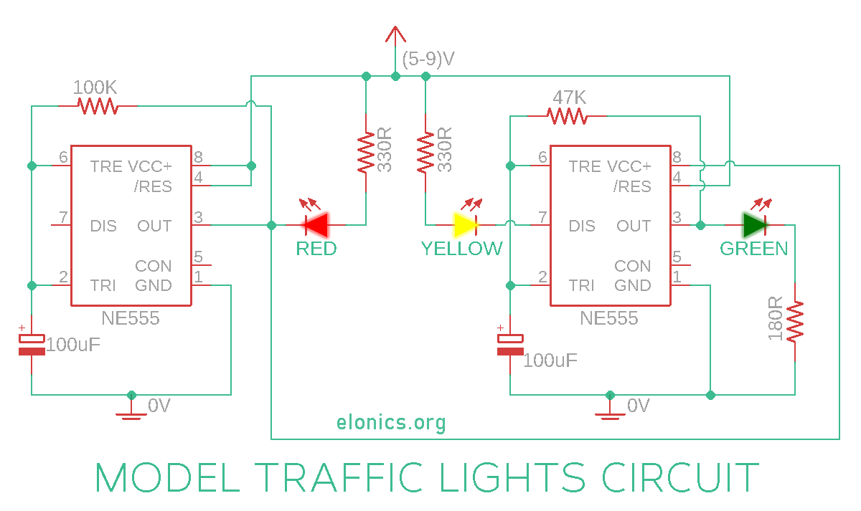

* **Circuit:**

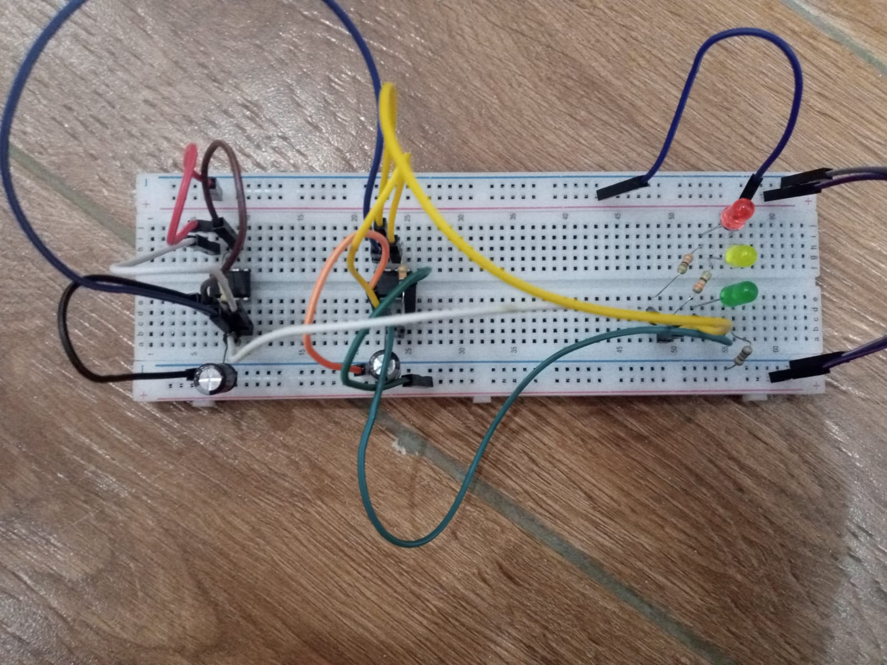

* **Components:**

1. 2 x 555 Timer ICs
2. LEDs: 1 Red, 1 Yellow, 1 Green
3. Resistors: 100K, 47K, 2 x 330R, 180R
4. Capacitors: 2 x 100uF
5. (5-12) V Power Supply

* **Future Enhancement of Application:**

There are several exciting avenues for enhancing this basic traffic light circuit using 555 timers:

1. **Traffic Detection:** Incorporate photoresistors or loop detectors to sense actual traffic flow. This enables dynamic timing adjustments based on real-time traffic conditions, optimizing flow and reducing congestion.
2. **Multi-way Intersection Support:** Expand the circuit to manage traffic lights for a four-way intersection. This would involve additional 555 timers and logic gates to create a more complex sequence for multiple traffic directions.
3. **Microcontroller Integration:** Introduce a microcontroller like the Arduino to control the 555 timers. This allows for even more sophisticated programming, enabling features like pedestrian crossing signals, countdown timers, and communication with central traffic management systems.
4. **Wireless Communication:** Integrate wireless modules like Bluetooth or LoRa to connect the traffic light circuit to a central network. This facilitates remote monitoring, data collection on traffic patterns, and potential coordination with other nearby traffic lights.
5. **Solar Power Integration:** Replace the traditional power supply with a solar panel and battery storage. This creates a self-powered and eco-friendly traffic light system, ideal for remote locations or areas with unreliable grid power.

* **Conclusion:**

In conclusion, this report has explored the design and functionality of a basic traffic light circuit constructed using 555 timer ICs. The circuit effectively replicates the sequence and timing of a real traffic light system with Red, Yellow, and Green LEDs, utilizing the astable mode of the 555 timers. This project provides a valuable introduction to electronics concepts like astable multivibrators, timing circuits, and LED control. Furthermore, the future enhancements discussed offer exciting possibilities for developing more intelligent and adaptable traffic management systems. By incorporating features like traffic detection, multi-way intersection support, and wireless communication, these advancements can contribute to improved traffic flow, reduced congestion, and enhanced safety on our roads.